**Sentiment Analysis**

Sentiment analysis is a natural language processing technique that involves analyzing and classifying the emotions or opinions expressed in text data. The goal of sentiment analysis is to determine the overall sentiment or attitude of the text, which could be positive, negative, or neutral. Sentiment analysis involves using machine learning and statistical techniques to identify and extract the sentiment from text data. This can be achieved by analyzing the words and phrases used in the text, as well as the context in which they are used. Some common methods used in sentiment analysis include rule-based systems, lexicon-based approaches, and machine-learning algorithms. Sentiment analysis can be used to analyze a wide range of text data, such as product reviews, social media posts, news articles, and customer feedback. It is used in various industries, including marketing, customer service, and product development, to gain insights into customer sentiment and opinions and to improve business strategies and decision-making.

The table below shows the sentiment of our sample data; the data consists of hundred rows from ten different accounts, such as Pashtun, Tajik, and Hazara. Most of the data were translated from the Persian language into English. The translation has been done through python and Google Translator.

|  |  |
| --- | --- |
| Sentiment | Percentage |
| positive | 47 |
| neutral | 30 |
| negative | 22 |

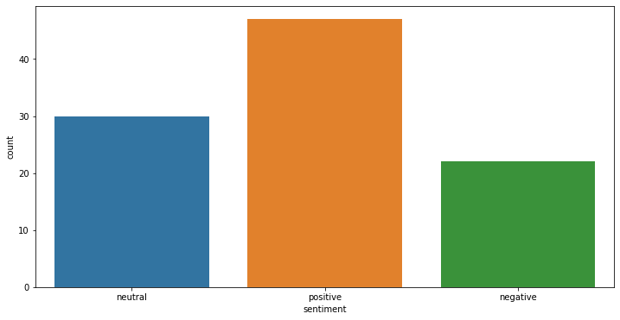The chart below shows the positive, negative and neutral graphs. In this chart, positive tweets are larger rather than negative ones.

The below table is the tweets from different accounts, the responses on women’s restriction, and almost most of the responses are on the Taliban side. People blame the Taliban for all these restrictions and education, even though there are responses on religion and culture.

|  |  |
| --- | --- |
| Text | Sentiment |
| We need a global action of the islamic community regarding the current situation and governance in **A**fghanistan the islamic community of the world should not allow a country with a hundred percent muslim population to be a mockery of Islam what the taliban are doing today is not compatible with any islamic principles | Negative |
| Seventeen months of the continued systematic erosion of women and girls and seventeen months of systematic abuse violence and discrimination The darkest day for Afghan women and girls | Neutral |
| Attack on girls school in dasht-barchi is the highest level of horror and brutality current violence amp uncertainty in the negotiation have created conductive environment for such savagery we strongly call again on taliban to return to the negotiation table amp end this bloodshed | Positive |

The table below shows the frequent words which appeared in our sample data. As the table shows, the most frequent word is “Taliban.”

|  |  |
| --- | --- |
| Frequent Word | Amount |
| Taliban | 53 |
| Education | 33 |
| Right | 28 |
| Girls | 26 |
| Afghanistan | 25 |
| Women | 20 |
| Islam | 18 |
| People | 16 |

Word cloud

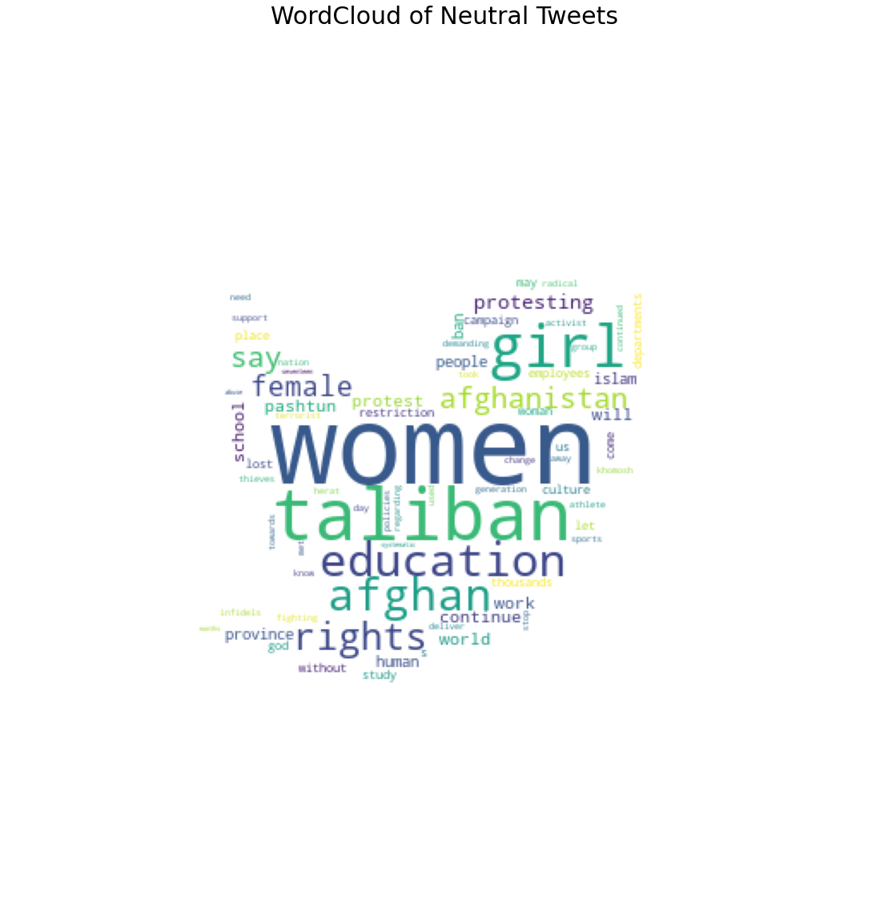

This chart shows the ethnicity and sex; on the left, the Tajik ethnic largely female, while on the left sex is Pashtun.

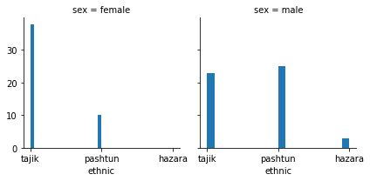

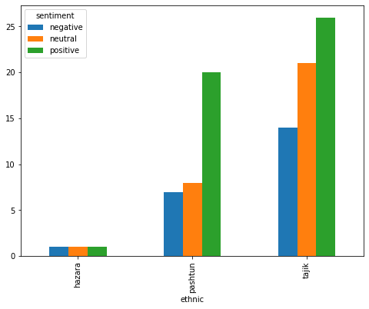This chart shows which ethnicity is more positive on women; as we see the Tajik is more positive, followed by Pashtun, Hazara has the lowest percentage, which could be due to fewer data. I did not add more data about Hazara.